Practical: - 6

Aim: - 1. Create an Employee (Empid, Name, dept), and Accounts (Empid, salary). define Empid as the primary key in Employee, also the foreign key from Accounts dept as NOT NULL, also check salary > 0.

2. Display the names of all employees having salaries greater than 10,000.

SQL> CREATE TABLE Employee (EmpID INT PRIMARY KEY,

Name VARCHAR (100),

Dept VARCHAR (20) NOT NULL,

CONSTRAINT fk_Employee_Accounts FOREIGN KEY (EmpID) REFERENCES Accounts (EmpID));

SQL>Desc Employee

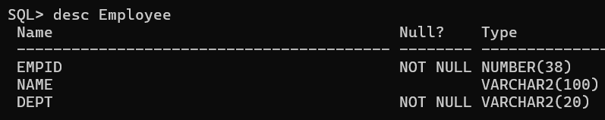

SQL> CREATE TABLE Accounts (EmpID INT PRIMARY KEY, Salary INT);

SQL> Desc Accounts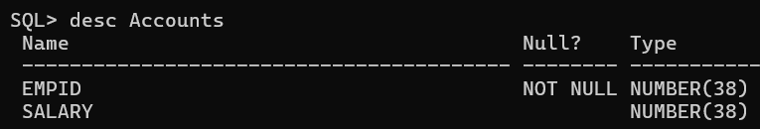

SQL> INSERT INTO Accounts (EmpID, Salary) VALUES (101, 7000);

SQL> INSERT INTO Accounts (EmpID, Salary) VALUES (102, 6000);

SQL> INSERT INTO Accounts (EmpID, Salary) VALUES (103, 11000);

SQL> INSERT INTO Accounts (EmpID, Salary) VALUES (104, 5500);

SQL> INSERT INTO Accounts (EmpID, Salary) VALUES (105, 12000);

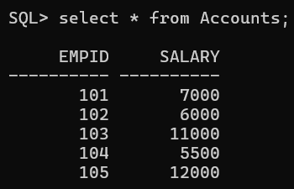SQL> select * from Accounts;

SQL> INSERT INTO Employee (EmpID, Name, Dept) VALUES (101, 'Ram', 'HR');

SQL> INSERT INTO Employee (EmpID, Name, Dept) VALUES (102, 'Rocky', 'Finance');

SQL> INSERT INTO Employee (EmpID, Name, Dept) VALUES (103, 'Ravi', 'IT');

SQL> INSERT INTO Employee (EmpID, Name, Dept) VALUES (104, 'Piyush', 'Marketing');

SQL> INSERT INTO Employee (EmpID, Name, Dept) VALUES (105, 'Anjali', 'Sales');

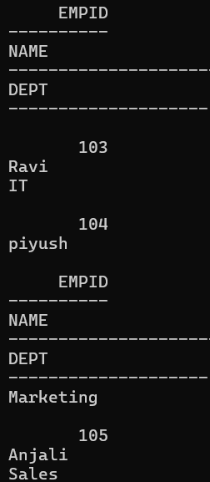SQL> select * from Employee;

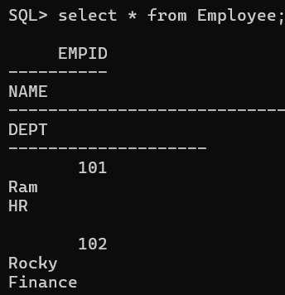

SQL> select Name from Employee, Accounts where Employee. EmpID=Accounts. EmpID

and salary > 10000;